Albemarle County Public Schools
Department of Human Resources


School Year 2010-2011 Annual Report
Annual Report
2011-2012
October 1, 2010 – September 30, 2011

October 1, 2010 – September 30, 2011

The Albemarle County Public Schools Department of Human Resources is pleased to provide the School Division Human Resources Annual Report. We appreciate the opportunity to share an overview of our department’s initiatives that support the School Division’s overall strategic plan. The report contains statistical information on the School Division’s workforce as well as highlighting some of the Human Resources Department’s accomplishments for the school year 2010-2011.

Key Information Provided:

- Recruitment and selection, retention, minority staffing, highly qualified staff and retirement data are provided separately for teachers, administrators and classified staff;
- Exit Survey Data;
- Compensation and Benefits.

To give students the very best learning experience we can offer, we will continue to focus on ensuring that our employees are performing at the highest level possible, whether in the classroom, the halls or a bus. The Department of Human Resources is dedicated to providing the highest quality human resource support to all customers. Over the next year, we will continue to focus on delivering results for Goal 3 of the School Division’s Strategic Plan: “Recruit, retain and develop a diverse cadre of the highest quality teaching personnel, staff and administrators.” By focusing our efforts on recruitment and retention, all facets of a student’s educational experience will improve, resulting in a positive impact in developing lifelong learners.

Lorna Gerome
Director
Human Resources
December, 2011
Table of Contents

Teacher Report 3
Administrator Report 10
Classified Staff Report 14
Exit Surveys 17
Compensation and Benefits 18
Going Forward 21
Teacher Report
Recruitment and Selection

The Human Resources Department continues to support the Albemarle County Public School Division Strategic Goal #3 in working to recruit, select and retain the best talent possible. From July 1, 2011 through September 30, 2011, the Albemarle County Public School Division hired 105 teachers. As the numbers below indicate, this was about a 46% increase (33 more teachers than in 2010) in the number of teachers hired this year compared to same time frame in 2010.

New Teacher Hires
2007 | 2008 | 2009 | 2010 | 2011
146 | 114 | 111 | 72 | 105

Of the 105 teachers hired:
- 10 (10%) are minorities
- 86 (82%) are full-time; 19 (18%) are part-time
- 63 (60%) had previous teaching experience
- 28 (27%) have more than five years of teaching experience
- 40 (38%) had previously taught in Virginia
- 43 (41%) are starting their teaching careers in the ACPS
- 65 (62%) have at least a master’s degree
- 78 (74%) are female; 27 (26%) are male
- 50 (48%) have three or more years of teaching experience
- 39 (37%) were hired for the elementary level
- 66 (63%) were hired for the middle and high school (secondary) levels.

From October 1, 2010 through September 30, 2011, the Human Resources Department had 927 individuals apply for teaching positions. This is about a 36% increase in applications from the 2009-2010 school years. The chart below provides information about the applicants.

Teacher Applications
 | Number of Applications | Percentage of Total | Identified as Highly Qualified | Percentage Identified as HQ
All | 927 | 100 | 751 | 81
White | 749 | 81 | 617 | 82
No Response | 104 | 11 | 83 | 80
Minority | 74 | 8 | 50 | 68

Each applicant has the choice to self‐identify his/her ethnicity. To be identified as “Highly Qualified” the applicant either held a Virginia teaching license at the time of their application or had obtained one by the end of September, 2011.
Highly Qualified Teachers

The No Child Left Behind law requires 100% of the teachers in “core” subject areas to meet specific criteria in order to be defined as “Highly Qualified”. The Albemarle County Public School Division had 99.61% of its teachers meet this requirement for the 2010‐2011 school year. The Virginia and U.S. Departments of Education accepted this percentage as a result of the number of localities that have struggled to reach the 100%. Concerted efforts were made during the summer hiring process to make sure that all new teachers would be considered Highly Qualified and that all teachers only teach in areas in which they are fully endorsed.

Minority Staffing

Currently there are 93 minority teachers. Even though 10% of the new hires were minority teachers this year, there was no change in the overall number of minority teachers in the School Division.

The first‐year minority teachers are graduates of the following schools (undergraduate and graduate respectively if applicable):
- University of Virginia & University of Virginia
- University of Virginia & Walden University
- Vanderbilt University & Harvard University
- University of California, Irvine & University of Virginia
- South Carolina State University

Veteran minority teachers are graduates of (again listed by undergraduate and graduate school):
- University of Virginia & University of Virginia
- University of Oklahoma & University of Oklahoma
- Quinnipiac University & Towson University
- University of Virginia

As can be seen in the following chart, college and university schools of education do not turn out a large number of minority graduates. Most counties and cities throughout the Commonwealth are striving to increase minority representation in their teaching staff, making competition for hiring minorities difficult as we are competing for the same population of candidates.

Education Graduates
School | Total # of Education Graduates 2010 | Total Minority Education Graduates 2010 | Percent 2010 | Total # of Education Graduates 2011 | Total Minority Education Graduates 2011 | Percent 2011
UVA | 235 | 21 | 8% | 239 | 30 | 13%
JMU | 305 | -- | -- | 244 | 17 | 7%
Virginia Tech | 111* | 4 | 3% | 118 | 8 | 7%
Mary Baldwin | 126 | 5 | 3% | 141 | 4 | 3%
Radford University | 329 | 12 | 3% | 248 | 17 | 7%
Longwood | 250 | 16 | 6% | -- | -- | --
*Includes administrative graduates
-- No information available

Eight percent of the teachers in the School Division are minorities, as compared to 17% of the residents and 30% of the student population. The statistical breakdowns can be seen in the following graph. The School Division continues to value the importance of diversity within teacher staffing. In a continuing effort to increase diversity, Albemarle County Public Schools has partnered with the African American Teaching Fellows. As it stands, the African American Teaching Fellows is the only consistent recruitment and hiring resource outside the traditional means of recruiting.

Retirements

From October 1, 2010 through September 30, 2011, 36 teachers retired compared to 30 retirements the previous year. To be eligible for a full VRS retirement with unreduced benefits, teachers must have at least 30 years of service in VRS and be at least 50 years old. This year, 58% of the retirees received full benefits compared to 50% the previous year. The following table shows the number of teacher retirements for the five year period from 2007 to 2011.

Retirees
2007 | 2008 | 2009 | 2010 | 2011
38 | 33 | 41 | 30 | 36
Note: The number in each bar is the actual number of teachers who left the School Division

Similar to the past several years, the average age of employees retiring after the 2010-2011 school year was 59.4. The age of this year’s retirees ranged from 51 to 70. The County’s Voluntary Early Retirement Incentive Program (VERIP) is designed for employees who have already met VRS retirement eligibility standards, but are not yet 65. This program provides eligible employees an “early” retirement option consisting of two types of benefits, both payable on a monthly basis for 5 years or until age 65, whichever comes first:

- Medical Contribution - A stipend equivalent to the School Board’s medical contribution given to active full-time employees
- VERIP Stipend - A benefit based on the difference between the estimated VRS benefit the employee would receive by retiring “early” and the benefit the employee would receive with 5 additional years of service

Staff members who retired at the end of the 2010-2011 school years were the last to receive the full 100% VERIP stipend. Beginning July 1, 2012, retiring staff members will receive only 80% of the stipend amount; however they will receive this amount for five years or until age 65, whichever is earlier. The phase-out schedule will reduce the amount of the stipend another 20% each subsequent year until it is eliminated in 2016-2017. The elimination of the VERIP stipend was the result of market data that indicated current benefits exceeded market levels. A cross-departmental workgroup established the phase-out schedule.

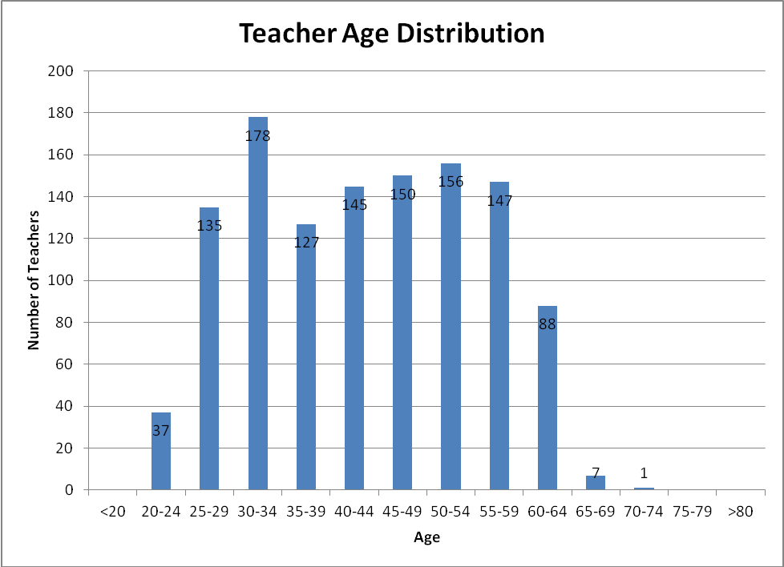
Note: The number in each bar is the actual number of teachers in the School Division.

This chart shows the age distribution of the teaching staff. Thirty-four percent of the teachers in the School Division are age 50 or older. The cumulative number of teachers (both full and part‐time) eligible to take advantage of VERIP over the next three years is as follows:
- June 2012: 277
- June 2013: 301
- June 2014: 328

The table below shows the number of full-time teachers who are currently eligible to retire with an unreduced VRS benefits and the additional teachers who will be eligible for full retirement at the end of each school year. At the end of the 2010-2011 school year, 72 teachers were eligible to retire with full benefits.

Teachers Eligible to Retire With Full VRS Payments
 | Current | End of  2011-12 | End of  2012-13 | End of  2013-14 | End of  2014-15 | End of  2015-16
Eligible to Retire with Full Benefits | 53 | 16 | 17 | 19 | 13 | 15
Running Total | 53 | 69 | 86 | 105 | 118 | 133

It should also be noted that as of September 2011, there were 104 full-time teachers at the pay step of T30 or above. This means that there are an additional 51 teachers who received credit for previous teaching experience or may have taught part time and are nearing retirement age, even though they may not be eligible at this time for an unreduced retirement from VRS. The average age of the 104 teachers is 59; the range of ages is 52-66.
Retention

Teacher retention rates over the past five years have been between 87.0% and 92.1%. For the 2010-2011 year, the retention rate was 89.1%. From October 1, 2010 through September 30, 2011, 126 teachers did not return to the School Division. This is the second highest number of teachers not returning in the last five years.

The graph below provides information on teacher turnover based on years of experience. In 2010-2011, 47 teachers who left the School Division had 0‐3 years of Albemarle County Public Schools teaching experience. This is the second lowest number of most recently hired teachers to leave the School Division in the past five years. This could be a result of the revised RIF policy, the continued efforts of the instructional coaches and the increased utilization of professional learning communities. In addition, a continuing weak economy and poor external job market may have contributed to the low rate of new teacher turnover.

Note: The number in each bar is the actual number of teachers who left the School Division, while the number above is the percentage of the total number of teachers in the School Division.

Of the 126 teachers who left the School Division in the 2010-2011 school year, 36 (28.6%) left for retirement, while 90 (71.4%) left for other reasons. As the chart below shows, the overall number of teachers leaving the School Division was the highest in three years. Even though 33 more teachers left the School Division than in the previous year, the percentage of teachers leaving with three years or less of teaching experience in the County Schools was the lowest in five years.

Exiting Teachers
Year | Teachers Leaving | Teachers Retiring | Percent of Teachers Retiring | Teachers Leaving for Other Reasons | Percent of Teachers Leaving for Other Reasons | Teachers Leaving With 0‐3 Yrs in ACPS | Percent of Teachers Leaving with 0-3 Years
2006‐07 | 151 | 38 | 25.2% | 113 | 74.8% | 75 | 50%
2007‐08 | 125 | 33 | 26.4% | 92 | 73.6% | 56 | 45%
2008‐09 | 123 | 41 | 33.3% | 82 | 66.7% | 54 | 44%
2009-10 | 93 | 30 | 32.2% | 63 | 67.7% | 35 | 38%
2010-11 | 126 | 36 | 28.6% | 90 | 71.4% | 47 | 37%

Summary

Overall, the number of teachers hired into the Albemarle County Public School Division for the 2010-2011 school year was the second lowest in five years. This is a trend that may continue for the 2012-2013 school year as a result of the continuing economic conditions. The number of teachers leaving the School Division at the end of the 2010-2011 year was the second highest in five years. A continuing area of concern is the number of teachers who could retire within the next several years. Over eleven percent of the current teaching staff could retire with a full VRS retirement within the next 5 years. There were 95 teachers (8%) age 60 or older at the start of the 2011-12 school year and almost nine percent (104 teachers) of the current teaching staff have been credited with 30 or more years of teaching experience. By the end of the 2011-2012 school year, 6.3% of the teaching staff could retire with full benefits under VRS. Additionally, continuing concerted efforts will be made to attract and hire minority candidates for teaching positions.
Administrator Report
Recruitment and Selection

Administrative staff includes principals, associate and assistant principals, and other leadership personnel throughout the School Division. For the purpose of this report, this includes executive directors, directors, and assistant directors of instruction and support programs, all coordinators, athletic directors, data analysts, environmental compliance managers, human resources managers, high school guidance directors, home school coordinators, and transportation managers.

From July 1, 2011 through September 30, 2011, the Albemarle County Public School Division filled only 3 assistant principal vacancies. Two of these were filled by hiring individuals from outside the School Division. The third vacancy was filled by promoting internally. Since this individual was not new to the School Division, he is not shown in the chart, as only external hires are shown in this table.

Administrative New Hires
 | 2007 | 2008 | 2009 | 2010 | 2011
Principals | 2 | 0 | 2 | 2 | 0
Asst./Assoc. Principals* | 3 | 3 | 1 | 3 | 2
Other Administrators | 2 | 1 | 2 | 3 | 0
Total | 7 | 4 | 5 | 8 | 2
*Includes Administrative Interns placed as Assistant/Associate Principals

Over the past five years, Albemarle County Public Schools has hired between 2 and 8 new administrators per year from outside the School Division. The hiring of only two external administrators is the lowest in 5 years.

Minority Staffing

Overall, about 18% of the administrative employees are minorities. This compares favorably with the overall County residents. About 21% of the principals and assistant principals are minorities. Though the number of African‐American administrative staff compares favorably, a concerted effort needs to be made to recruit Asian and Hispanic administrators to better reflect the School Division’s changing demographics.

Retirements

The chart below shows the number of administrative retirements for the five‐year period from 2007 to 2011. A targeted retirement incentive for eligible employees in pay grade 16 and above was offered in 2010. The three administrators who retired in 2011 included one assistant principal and two central office administrators.

Administrative Retirees
2007 | 2008 | 2009 | 2010 | 2011
7 | 4 | 8 | 9 | 3

As the graph below illustrates, the School Division’s administrative staff is also impacted by an aging workforce. Thirty eight percent of the administrators are age 50 or older. Based on this data, an increase in retirements for the future years can be anticipated.

The cumulative number of administrators (both full and part‐time) eligible to take advantage of the Voluntary Early Retirement Program (VERIP) over the next three years is as follows:

- June 2012: 23
- June 2013: 24
- June 2014: 28

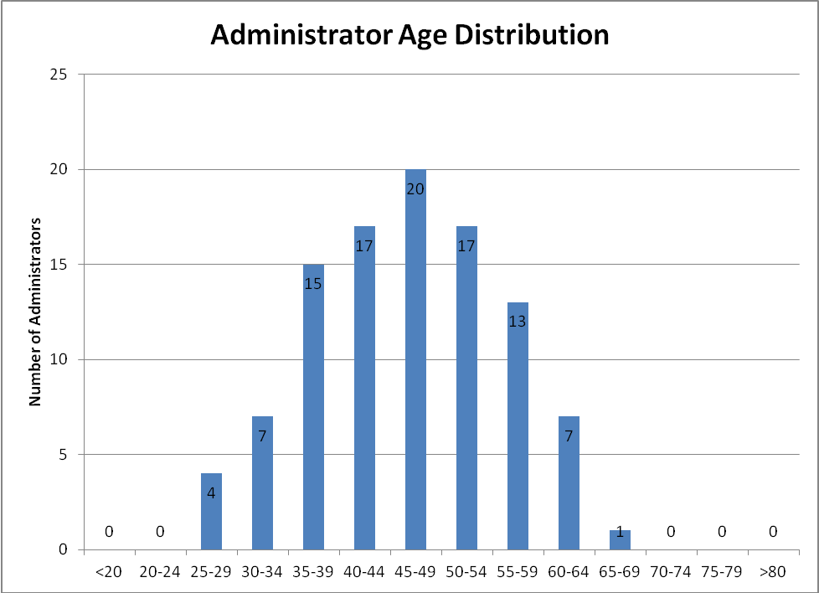
Note: The number in each bar is the actual number of administrators in the School Division.

Building level administrators (principals, assistant and associate principals, guidance directors and athletic directors) are also eligible to retire with unreduced benefits once they have at least 30 years of service with VRS and are at least 50 years old. The table below shows the actual number of full-time building level administrators who have or will have 30 years by the end of each school year. The number in the current column is the number of building level administrators working for the Albemarle County Public School Division who were eligible to retire with full benefits at the start of the 2010-2011 school year. This underscores the need to focus on planning for retirements in the upcoming years. Overall, in the next five years, 16% of the principals and 20% of the assistant principals will be eligible to retire with unreduced VRS benefits.

Administrators Eligible to Retire With Full VRS Payments
 | Current | End of  2011-12 | End of  2012-13 | End of  2013-14 | End of  2014-15 | End of 2015-16
Eligible to Retire with  Full Benefits | 5 | 0 | 2 | 0 | 0 | 1
Running Total | 5 | 5 | 7 | 7 | 7 | 8

Retention

Retention rates for administrators over the past five years have been between 87.6% and 92.2%. This year’s rate, 92.2%, is the highest in the last five years and higher than last year’s rate of 87.6%. Of the eight administrators who left the School Division, three were retirees (37.5%).

Summary

The number of administrators hired into the Albemarle County Public School Division for the 2011-2012 school year was the lowest in five years. In addition, the number of administrators who retired was also the lowest in five years. A continuing area of concern is the number of building-level administrators who could retire within the next five years. Of the five currently eligible to retire with full retirement benefits, three are principals, and two are assistant principals. Additionally, continued efforts will be made to attract minority candidates for building level administrative positions. A particularly positive statistic is the number of minority building level administrators. About 27% of the School Division’s assistant principals are minorities, while 16% of the principals are minorities, which exceeds the goals for this area.

Classified Staff Report
Recruitment and Selection

Classified employees include all the non‐teacher and non‐administrative positions in the School Division. Examples include all non‐administrative employees in Transportation, Building Services, Child Nutrition, and Extended‐Day Programs. Office associates, school nurses and teaching assistants (TA’s) are also considered classified employees.

From July 1, 2011 through September 30, 2011, the Albemarle County Public School Division hired 135 classified employees. It should be noted that classified employees are hired throughout the school year, while most teacher and administrative hiring occurs during the timeframe of July 1 through September 30. As the numbers in the table below indicate, there has been a decrease in the number of classified employees hired this year when compared to the last two years. It should be noted that the large number of hires in 2009 was due in part to the large number of vacancies resulting from the retirement incentive offered at the end of the 2008 school year and the fact that there were two dozen frozen positions from the previous year that were filled.

Classified Staff New Hires
2007 | 2008 | 2009 | 2010 | 2011
110 | 92 | 172 | 149 | 135

Minority Staffing

The School Division continues to recruit and hire qualified candidates from all ethnic groups. The following graph provides a breakdown of the School Division’s classified staff population compared to the County’s overall population and the School Division’s student population.

Retirements

Since September 30, 2010, 25 classified employees retired compared to 13 retirements the previous year. As the chart below indicates, retirements in 2009 were considerably higher than in other years. This can be attributed to the retirement incentive offered that year to all eligible employees.

Classified Staff Retirements
2007 | 2008 | 2009 | 2010 | 2011
21 | 23 | 66 | 13 | 25

As the graph below indicates, the largest number of classified employees is in the 50-54 age group. In addition, it should be noted that 49% of the current classified employees are age 50 or older. Within the next five years, there are only 10 classified employees who will be eligible for unreduced VRS retirement benefits. This may be a reflection of the fact that less than 50% of classified employees are full-time.

The cumulative number of classified employees (both full and part‐time) eligible to take advantage of the Voluntary Early Retirement Program (VERIP) over the next three years is as follows:

- June 2012: 216
- June 2013: 241
- June 2014: 250
Retention

Retention rates for classified staff over the past five years have been between 79.4% and 83.5%. This year’s retention was 79.4% compared to 83.5% last year. The number of retirees increased from 13 to 25 and the retention rate decreased. It is important to continue to focus on retention by:

- Improving communications within work groups and among employees;
- Providing training and development opportunities through courses offered;
- Increasing participation in the exit process to identify possible areas to target retention initiatives; and
- Providing training to supervisors/managers to increase skill‐sets in core competency areas.

Of the 218 classified employees who left the School Division from October 1, 2010 through September 30, 2011, 15% had less than one year of experience with the School Division. This was a major decrease from the previous year, when 45% of the departing classified employees had less than one year of experience. Of the employees who left the School Division, 40% were TA’s. Overall, TA’s represent 32% of the classified workforce. Of those nearly 71% are part time employees. Seventy-six percent of the departing classified employees were at pay grade 6 or less. Throughout the School Division, about 60% of the classified jobs are at a pay grade of 6 or less.

Summary

Overall, the number of classified employees hired into the Albemarle County Public School Division for the 2010-2011 school year is down from the previous year. Consistent with national trends, an area of concern for the School Division is the number of classified employees who might retire within the next five to ten years, as illustrated by the graph of employee ages. The low retention rate is also an area of concern. In order for new hires to be able to successfully meet job requirements, extensive training is needed.
Exit Surveys

Survey data was collected for exiting employees occurring October 1, 2010 through September 30, 2011. Again this year due to budget constraints, Human Resources collected and analyzed the survey data, rather than contracting with an outside vendor. Staff made multiple attempts to contact exiting employees. One-hundred and fifty employees responded to the survey. Fifty-eight percent of the departing teachers and 34% of the departing classified employees completed the survey.

The findings of the exit surveys indicate that 87% of the respondents were favorable in regard to their overall work experience in the Albemarle County Public Schools. Only 7% of the employees responded that their overall experience was unfavorable, while 6% were neutral. This is a six percent increase in the overall positive responses when compared to the responses from 2009-2010 surveys and a two percent decrease in the negative responses. Each responding employee was asked his/her primary reason for leaving from among the following and was allowed to select only one response: salary/benefits package; relocation; retirement; lack of training or career opportunities; leaving profession; supervision/management issues; or reasons external to the system (i.e. personal). Survey results are shown below.

Exit Surveys: Employees’ Primary Reasons for Leaving
Reason | Classified/  Administration (71)* | Teachers (71)* | All Employees (142)*
Reasons external to system | 28% | 30% | 29%
Retirement | 14% | 25% | 20%
Relocation | 16% | 20% | 18%
Salary/Benefits Package | 24% | 7% | 15%
Supervision/Management Issues | 10% | 13% | 11%
Lack of Training/Opportunities | 7% | 4% | 6%
Leaving Profession | 1% | 1% | 1%
*Number of respondents for this particular survey question

As in the previous two years, Work Satisfaction scores among exiting employees remain relatively high. Pay/Benefits is still an area of dissatisfaction based on the survey results. This dissatisfaction may be linked to the fact that there had not been any pay raises for School Division employees in three years. Salary/Benefits was given as the primary reason for 24% of the classified employees leaving the School Division. Teacher response to Work Satisfaction was 81% positive while Classified/ Administration was 77%. It should be noted that the Work Satisfaction aspect of employment saw a 5% decrease in positive responses from departing teachers when compared with the previous year.

It is interesting to note that with almost twice as many completed surveys as last year, the overall responses changed very little. Only two areas showed declines in positive responses, Work Distribution/Schedule Flexibility and Career Advancement opportunities.

Aspect of Employment | Exiting Employees Favorable Response
 | 2008-2009 | 2009-2010 | 2010-2011
1. Work Satisfaction | 83% | 78% | 79%
2. Work Distribution/Schedule Flexibility | 70% | 73% | 66%
3. Pay/Benefits | 73% | 57% | 57%
4. Training and Development | 71% | 60% | 60%
5. Career Advancement Opportunities | 56% | 48% | 46%
6. Supervisory Consideration | 66% | 61% | 67%
7. Work Group Communication | 70% | 62% | 66%
8. Organizational Culture* | 71% | 44% | 55%
* Organizational Culture measures how the respondents feel about the organization’s direction and its employees.

Compensation and Benefits

Joint Boards Adopted Total Compensation Strategy

The School Board and Board of Supervisors’ Total Compensation Strategies are to target employee salaries at 100% of the competitive market median, teacher salaries at the top quartile, and benefits slightly above the market. The Joint Boards follow a process to establish the annual merit increase, teachers’ step and scale increases, and classified salary scale adjustment. Even though there were no salary increases during the 2010-2011 school year, all eligible employees received a one-time $350 lump sum bonus. For the 2011-2012 school year, classified employees received a 1% salary increase. The teacher scale was increased by an average of 1.95%, based on market data. The classified scale was not increased.

Long Term Classification Plan

To ensure that positions are appropriately classified, HR began comprehensive reviews of all departments on an ongoing basis in July 2004. Priorities are based on identified internal equity issues, substantial changes in position descriptions, and market data. This year, the DART department reorganization required that most positions be reviewed for appropriate classification.

Benefits Administration

The School Division offers a wide range of benefit options that promote a healthy lifestyle and contribute to financial stability. Benefits offered include: medical, dental, deferred compensation, flexible spending accounts (Beneplus), optional life insurance, direct deposit, family medical leave, employee discounts, and paid leave (annual, sick, sick leave bank, etc.). Pension and life insurance plans for full‐time employees are offered through the Virginia Retirement System (VRS) and for part‐time employees through other vendors.
To increase employee understanding and appreciation of their benefit package, HR continues to refine the online Open Enrollment website and communicate to employees through various methods, including:
- Offering benefits orientation and refresher sessions
- Information on the website/intranet
- Financial education and pre‐retirement seminars
- Monthly on‐site availability of our deferred compensation vendor representative and informational workshops

This year, HR focused on obtaining employee feedback on the benefit programs by conducting a survey and focus groups. This information is used to guide the design of our benefit programs.

Health, Safety, and Wellness

Efforts in the areas of occupational health, safety and wellness are becoming ingrained into the culture for the School Division.

Occupational Health &Safety: It is apparent that employees are taking responsibility for their own safety and the safety of their work environment. Two departments have started their own internal safety teams and as a result, the frequency of accidents has decreased. Building Services custodial staff and the employees of Transportation have dedicated their time to identifying and preventing workplace accidents for their staff. In addition, a regulatory audit conducted in Transportation did not identify any serious workplace safety issues. The items that were identified were corrected by staff within 7 days, thus emphasizing the importance of safety in the work environment.

Bus driver physical exams are being completed in-house and as a result, there has been a 33% decrease in cost of services.

Wellness: The mission of the Wellness Team is: To provide opportunities that will promote and improve the overall wellness of employees and their families. To support this mission, a medically supervised weight loss program was created. This was a collaborative effort with Southern Health, ACAC and several local healthcare providers. To date, 65 School Division employees have completed the 6-month program that includes weekly educational meeting to address nutrition and behavioral changes and 3-5 months of an exercise program. The positive lifestyle changes that have occurred should impact future healthcare expenditures.

A variety of additional wellness programs have been offered at various locations throughout the County. Examples include:
- Flu shots
- Mobile Mammography
- Weight Watchers at Work
- Smoking Cessation Program sponsored by our local Health Department
- FIT Extension sponsored by the Virginia Cooperative Extension Office
- Charlottesville’s Women’s and Men’s 4‐Miler events

Training

System‐wide professional development activities are offered for teachers and administrators through the Albemarle Resource Center. Because there were very few professional development opportunities offered for classified employees, beginning with the 2006‐2007 school year, the School Division provided funding for classified employees’ professional development through Human Resources. For fall 2010 and spring 2011, School Division classified employees attended 96 different classes, totaling more than 1,122 hours of class time. Classes included:
- How to Do a Project Post-Mortem
- Intermediate Outlook 2007: Email Management and Efficiency
- How to Reward and Recognize Employees
- Cardio Pulmonary Resuscitation
- Editing and Using Pictures in Microsoft Office 2007
- Leadership Foundations
- Teamwork 101
- Customer Service and the FISH Story

In addition, Human Resources regularly offered and provided training to hundreds of employees in the following subject areas: new employee orientation, on-line annual training, retirement planning, interviewing (legal issues and interviewing skills), safety awareness/OSHA training, and sexual harassment training.

Annual Service Awards

The School Division annually recognizes employees for their continuous years of service with the School Division. As in years past, employee recognition was conducted at the employee's school or department. Feedback has indicated that this personalized form of recognition is greatly valued by employees. All recognized employees received a framed certificate. In addition, recognition gifts were presented for 10, 15, 20, and 25+ years of service as follows:
- 10, 15, and 20 years of service: employees received an attractive gift
- 25+ years: employees chose from a selection of gifts that best suited their preferences
- Employees with the greatest length of service and reached a milestone this year were recognized with a special presentation and gift at the Employee Recognition Ceremony

This year, 381 employees were recognized for their service milestones that occurred between October 1, 2010 and September 30, 2011. Of these 381 employees, 166 were recognized for 5 years of service, 88 for 10 years, 44 for 15 years, 27 for 20 years, 32 for 25 years, 20 for 30 years, 3 for 35 years, and 1 employee was recognized for 40 years of dedicated service with the Albemarle County Public Schools.
Going Forward
Human Resources is committed to helping the School Division accomplish its mission and support the overall strategic plan and will continue to work to meet identified strategies as indicated.

For Goal 3: Recruit, retain and develop a diverse cadre of the highest quality teaching personnel, staff, and administrators. These efforts include:
- Developing and implementing a comprehensive plan to recruit and retain the highest quality teaching personnel, staff and administrators
- Supporting the establishment of an individual goal for recruitment and/or retention to address the diversity needs for each school
- Exploring and initiating 21st century approaches to recruitment efforts
- Increasing the ratio of minority hires to minority exits for teaching and for supervisory/leadership positions
- Providing effective training and development for classified staff to meet current and future needs
- Continuing to meet market targets for the County’s total compensation strategy, to include evaluating market competitiveness of salary and benefit programs
- Implementing desired voluntary benefits, based on employee feedback, such as long term care, long term disability and offer enhanced options to existing benefits, such as the flexible benefits account card
- Addressing areas of improvement identified in the exit survey and upcoming climate survey
- Ensuring performance management systems (Teacher Performance Appraisal, Classified Employee Evaluation System, Teaching Assistant Performance Evaluation Pilot) are aligned with Division goals.

For Goal 5: Establish efficient systems for development, allocation and alignment of resources to support the Division’s vision, mission, and goals. These efforts include:
- Conducting reviews of pay practices to ensure compliance and create organizational efficiencies
- Continuing an internal audit of HR practices and procedures
- Providing support and training as HR prepares for the scheduled implementation of Access Albemarle in 2012.

